A Project Report On

Driver Drowsiness Detection

Submitted in partial fulfillment of requirement

for the award of the degree

MASTER OF COMPUTER APPLICATIONS

of

Visvesvaraya Technological University, Belagavi

By

(PRAJWAL B S 4NM20MC063)

2020-2022



(An Autonomous Institution affiliated to VTU, Belagavi)

Nitte Mahalinga Adyanthaya Memorial Institute of Technology

Nitte – 574110, Karkala, Udupi District

A Project Report On

Driver Drowsiness Detection

Submitted in partial fulfillment of requirement

for the award of the degree

MASTER OF COMPUTER APPLICATIONS

of

Visvesvaraya Technological University, Belagavi

By

(PRAJWAL B S 4NM20MC063)

2020-2022

Under the guidance of

Internal Guide External Guide

**Mrs. Sarita Shetty** Mr. A Khan

Assistant Professor **Guide& Head**

**Department of MCA** Cognitive Solutions

**NMAM Institute of Technology, Nitte Mangalore**



(An Autonomous Institution affiliated to VTU, Belagavi)

Nitte Mahalinga Adyanthaya Memorial Institute of Technology

Nitte – 574110, Karkala, Udupi District

Nitte Mahalinga Adyanthaya Memorial Institute of Technology

Nitte – 574110, Karkala, Udupi District

2020-2022



(An Autonomous Institution affiliated to VTU, Belagavi)

CERTIFICATE

This is to certify that the project entitled

Driver Drowsiness Detection

Submitted in partial fulfillment of requirement

For the award of the degree

MASTER OF COMPUTER APPLICATIONS

Is result of the bonafide work carried by

PRAJWAL B S 4NM20MC063

During the academic year 2021-2022

Internal Guide External Guide

Mrs. Sarita Shetty Mr. A Khan

Assistant Professor Guide & Head

Department of MCA Cognitive Solutions

NMAM Institute of Technology, Nitte Mangalore

Dr. Surendra Shetty Dr.Niranjan N Chiplunkar

Professor & Head Principal

Department of MCA NMAM Institute of Technology, Nitte

NMAM Institute of Technology, Nitte

Semester End Viva Voce Examinations

Name Of the examiners Signature with date

1.

2.

**Acknowledgements**

We are profoundly grateful to Mr. A Khan for his expert guidance and continuous encouragement throughout to see that this project rights its target since its commencement to its completion. .....................

PRAJWAL B S

**Table of Contents**

**CHAPTER NO. TITLE PAGE NO.**

**1. INTRODUCTION 1-2**

* 1. **Problem Introduction**
  2. **Problem Definition**

**2. Literature Survey 3**

**2.1 System Review**

**2.2 TECHNOLOGY USED**

**3. System Design 4-5**

**3.1 Existing System with limitations**

**3.2 Proposed System with objectives**

**3.3 Feasibility Study**

**4. System Analysis 6-7**

**4.1 Requirement Specification**

**4.2 Software and Hardware Requirements**

**5. System Design 8-9**

**5.1 Use Case Diagram**

**5.2 Activity Diagram**

**6. Detailed Design 10**

**7 System Implementation 11-12**

**8 Testing and Result 13-14**

**9 Conclusion 15**

**10 Future Enhancement 16**

**11 Bibliograph 17**

**Abstract**

The main reason for motor vehicular accidents is the driver drowsiness. Drowsiness and Fatigue of drivers are amongst the significant causes of road accidents. Every year, they increase the amounts of deaths and fatalities injuries globally. This project is proposed to reduce the number of accidents due to drivers’ fatigue and hence increase the transportation safety; this system deals with automatic driver drowsiness detection based on visual information and Artificial Intelligence. We propose an algorithm to locate, track, and analyze both the drivers face and eyes to measure PERCLOS, a scientifically supported measure of drowsiness associated with slow eye closure. Whereas the implementation of the project gives the real-world idea of how the system works and what changes can be done in order to improve the utility of the overall system

**1.INTRODUCTION**

* 1. **Project Introduction:**

Humans have always invented machines and devised techniques to ease and protect their lives, for mundane activities like traveling to work, or for more interesting purposes like aircraft travel. With the advancement in technology, modes of transportation kept on advancing and our dependency on it started increasing exponentially. It has greatly affected our lives as we know it. Now, we can travel to places at a pace that even our grandparents wouldn’t have thought possible. In modern times, almost everyone in this world uses some sort of transportation every day. Some people are rich enough to have their own vehicles while others use public transportation. However, there are some rules and codes of conduct for those who drive irrespective of their social status. One of them is staying alert and active while driving. Neglecting our duties towards safer travel has enabled hundreds of thousands of tragedies to get associated with this wonderful invention every year. It may seem like a trivial thing to most folks but following rules and regulations on the road is of utmost importance. While on road, an automobile wields the most power and in irresponsible hands, it can be destructive and sometimes, that carelessness can harm lives even of the people on the road. One kind of carelessness is not admitting when we are too tired to drive. In order to monitor and prevent a destructive outcome from such negligence, many researchers have written research papers on driver drowsiness detection systems. But at times, some of the points and observations made by the system are not accurate enough. Hence, to provide data and another perspective on the problem at hand, in order to improve their implementations and to further optimize the solution, this project has been done.

There are many products out there that provide the measure of fatigue level in the drivers which are implemented in many vehicles. The driver drowsiness detection system provides the similar functionality but with better results and additional benefits. Also, it alerts the user on reaching a certain saturation point of the drowsiness measure.

* 1. **Problem Definition:**

Fatigue is a safety problem that has not yet been deeply tackled by any country in the world mainly because of its nature. Fatigue, in general, is very difficult to measure or observe unlike alcohol and drugs, which have clear key indicators and tests that are available easily. Probably, the best solutions to this problem are awareness about fatigue-related accidents and promoting drivers to admit fatigue when needed. The former is hard and much more expensive to achieve, and the latter is not possible without the former as driving for long hours is very lucrative.

**2.** **Literature Survey**

**2.1 SYSTEM REVIEW:**

This survey is done to comprehend the need and prerequisite of the general population, and to do as such, we went through different sites and applications and looked for the fundamental data. Based on these data, we made an audit that helped us get new thoughts and make different arrangements for our task. We reached the decision that there is a need of such application and felt that there is a decent extent of progress in this field too.

**2.2 TECHNOLOGY USED:**

1. **Python:**

Python is an interpreted, high-level, general-purpose programming language. Python's design philosophy emphasizes code readability with its notable use of significant whitespace. Its language constructs and object-oriented approach aim to help programmers write clear, logical code for small and large-scale projects. Python is dynamically typed AND supports multiple programming paradigms, including procedural, object-oriented, and functional programming.

1. **IMAGE PROCESSING:**

In computer science, digital image processing is the use of computer algorithms to perform image processing on digital images.

1. **MACHINE LEARNING:**

Machine learning is the scientific study of algorithms and statistical models that computer systems use in order to perform a specific task effectively without using explicit instructions, relying on patterns and inference instead. It is seen as a subset of artificial intelligence.

**3. SYSTEM DESIGN**

**3.1 Existing System with limitations:**

The existing system of driver drowsiness detection system has following disadvantages. Mainly, using of two cameras in the system one for monitoring the head movement and the other one for facial. The other disadvantage is aging of sensors and all these sensors are attached to the driver’s body which may affect the driver. And also, which cost high to implement in a car. Because of this the price of vehicles go high so normal people can’t afford that, they go for cheap one with no technology which may leads to accident.

So, to overcome all these disadvantages we designed a system in which a live camera is used for monitoring the driver drowsiness condition and alert the driver which reduces the road accidents.

* 1. **Proposed System with objectives:**

In order to overcome disadvantages of existing systems with some machine learning tools developed and highly operable device. As compared to existed device it is of less cost and highly advanced. It will trigger an alarm once it finds out that driver is sleeping. And also contact the creatin people that are in emergency contact. It will reach them through text message through their number as well as what’s app message and also email the particular people so they can act fast as well.

In my project it is mainly concentrated on alerting driver and emergency contact as soon as possible. In this I have used OpenCV of python to predict either the driver felling sleepy or active based on eyes distance. That are calculated through **Euclidean Distance** using positions of each eye.

* 1. **Feasibility Studies:**
     1. **Technical feasibility:**

In our project we got every technical aspect that we are I need. Like webcam and good processor and alarm system and fully communicable devices. It all work really well to produce best output. It will produce accurate decision most of the time like in display it’s always shows the distance of eyes each time when you close your eye and open it. This project isn’t technically feasible.

* + 1. **Financial feasibility:**

Our project is financially viable everyone can afford that.it won’t cost that much compare to other systems. Recent coming vehicles are all coming with camera an all-required stuffs like alarm system and fully communicable devices. So, we don’t need to pay some extra money for some of technical resource.

* + 1. **Operational feasibility:**

Our project completely ready and it is operable. It took some more time to develop as we planned but eventually, we did it within submission time. We got all the required resources.

**4**.**SYSTEM ANALYSIS**

**4.1 Requirement Specifications:**

**4.1.1 Functional Requirement:**

* User should get good result in some tricky situation.
* It should work low light.

**4.1.2 Non-functional Requirements**:

* Maintainability: The software must support for the future updates like to get more enhancements.

**4.2 Software and Hardware Requirements:**

**4.2.1 Software Requirements:**

**4.2.1 Python**

Python is the basis of the program that we wrote. It utilizes many of the python libraries.

**4.2.2 Libraries:**

* **SciPy**: SciPy stands for Scientific Python. It provides more utility functions for optimization, stats and signal processing. Like NumPy, SciPy is open source so we can use it freely. In this project we used this on for calculating Euclidean distance between the eyelids.
* **Imutils:** This package includes a series of OpenCV + convenience functions that perform basics tasks such as translation, rotation, resizing, and skeletonization.
* **Dlib:** Itis a modern C++ toolkit containing machine learning algorithms and tools for creating complex software in C++ to solve real world problems. It is used in both industry and academia in a wide range of domains including robotics, embedded devices, mobile phones, and large high performance computing environments. In this we used to find the frontal human face and estimate its pose using 68 face landmarks.
* **Smtplib:** It is a Python library for sending emails using the Simple Mail Transfer Protocol (SMTP). The smtplib is a built-in module.
* **Twilio:** It is a library for sending text messages and WhatsApp messages. It is third party where we use api keys to do the messaging process.

**5 SYSTEM DESIGN**

**5.1 Use Case Diagram:**

CAMERA

Driver

Facial Processing

Drowsiness Detection

**5.2 Activity Diagram:**

Initialize System

Video Capture

Extract Frames

No

Extract Features

Access Threat

Track Features

yes

Report Threat

**6.Detailed Design**

The proposed system relies on three main features of a driver’s eyes. We have chosen the popular 68 face-landmarks dataset with dlib. Where we are going to get our faces 68 landmarks through which we used only suitable for our project which is eyes side so we chose only those parts out of all land marks.

By using those landmarks, we going calculate some of distance between those eyes and based on that we are going to tell either the driver is asleep or awake. We also used some best libraries like imutils, dlib, Twilio for good results. Where imutils is used for some good information like common face detectionmodels. It also provides multiple face utilities such as face cropping, retina face models. You can also zoom in and out from the face.

We also used dlib for It’s a landmark’s facial detector with pre-trained models, the dlib is used to estimate the location of 68 coordinates (x, y) that map the facial points on a person’s face like image. We get exact distance and accuracy. It produces good values as compared to other libraries.

We used Twilio for our communication purposes. It’s the third-party website that we are using in our project. Using this we communicate with the emergency contacts. We used api keys to do such things like text messaging and WhatsApp messaging.

We used smtplib for sending an email to particular people that are in the list of emergency contacts. To make alert sound we used pygame libraries. We used wav format sound to make alarm to driver if he goes to sleep.

**7. SYSTEM IMPLEMENTATION**

## **7.1 Dlib's 68 Face Features:**

The below image is an example of a Dlib's 68 points model. There we can see those points from 1 to 68. But sometimes we don't need all 68 feature points, then for that, we will do in the next post, how we can customize those points according to our requirements. In this post, we only going to see about 68 Dlib's points for clear understanding.

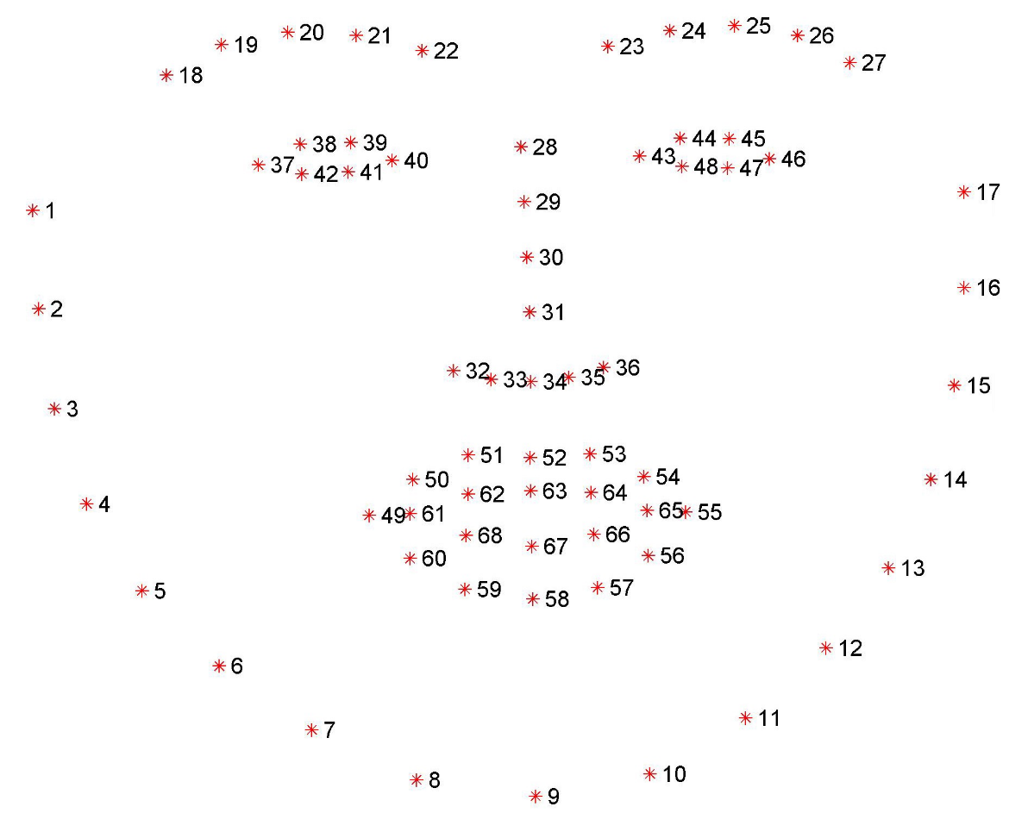

In our project we only used the required points like eyes points. We calculate the distance of eye based on that we declare either the driver is sleepy or awake. After passing our video feed to the dlib frame by frame, we are able to detect left eye and right eye features of the face. After that we draw only contours around eyes using OpenCV.

Using SciPy’s Euclidean function, we calculated sum of both eyes’ aspect ratio which is the sum of 2 distinct vertical distances between the eyelids divided by its horizontal distance.

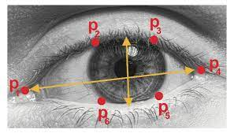

Each eye has 6 points through which we calculate the distance. After that we calculate the aspect ratio of that eyes. Using aspect ratio, we calculate the frame check through which we decide driver is sleep or not. Minimum frame check 30 about 30 it will give alert message and alarm as well as messaging process.

**8 Testing and Result**

**8.1 Initial Start Alarm:**

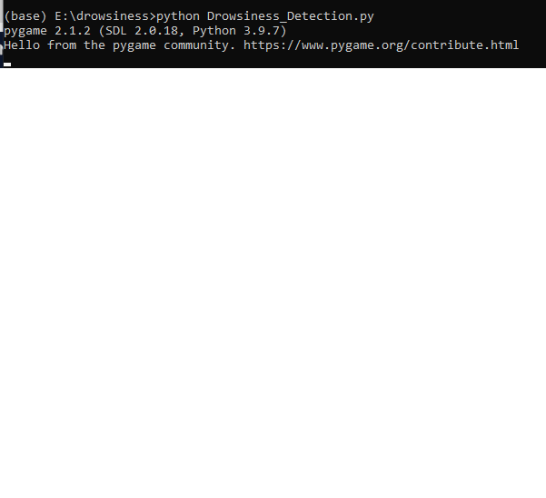

In the above result we can hear about a start of procedure with an alarm.

**8.2 Non-Drowsy Driver with frame value:**

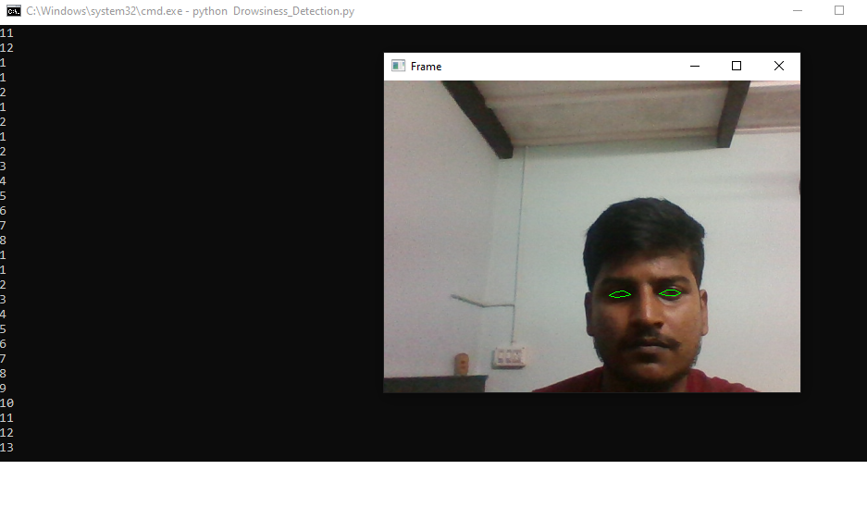

In the above result we can see those green points throughout the eyes. And also, we can see the frame check value in the background.

**8.3 Feeling Sleepy Driver:** 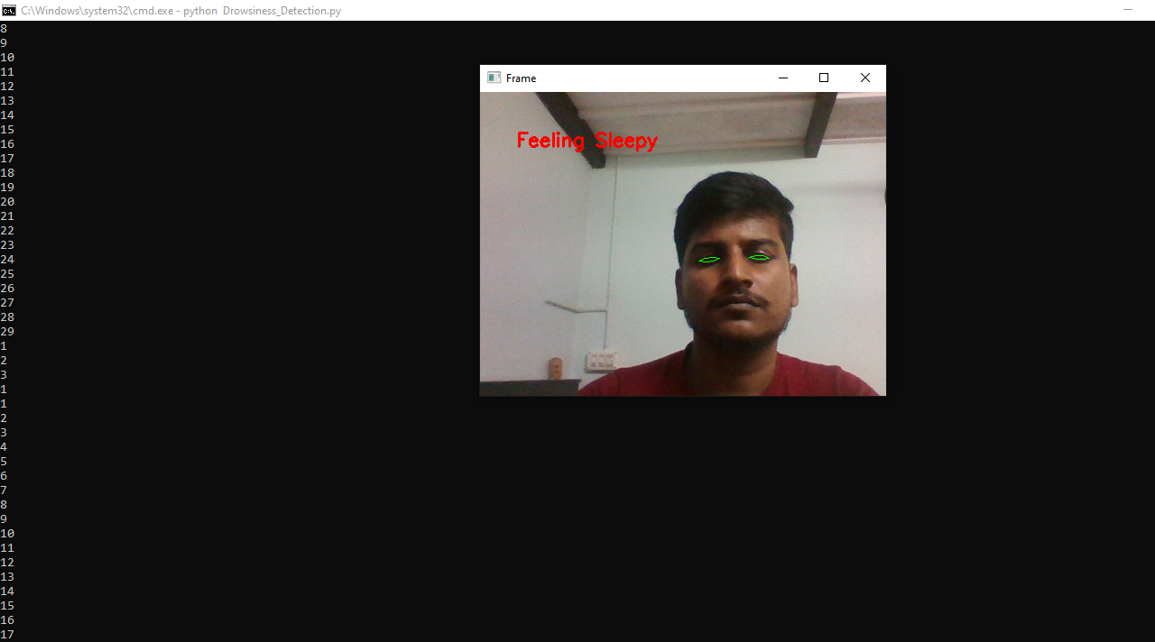

In the above result we can see the driver sleepy we can see his eyes and also the frame check values is it between 10-30 it’ll give as feeling sleepy.

**8.4 Drowsy Driver:**

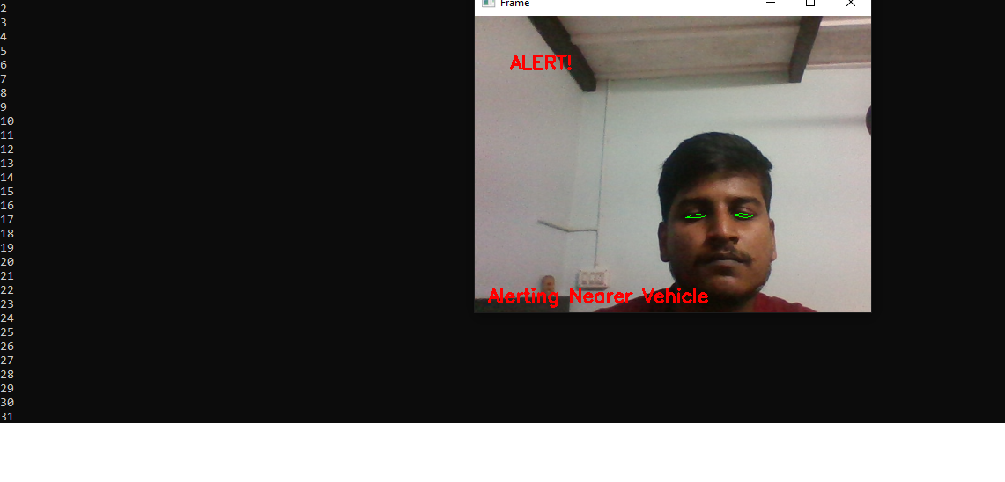

In the above result we can see the driver is completely sleepy we can see his eyes and also the frame check values is it above 30 it’ll give those messages like alert and alerting near vehicle.

Messages that are triggered due to sleepiness of driver

Text Message

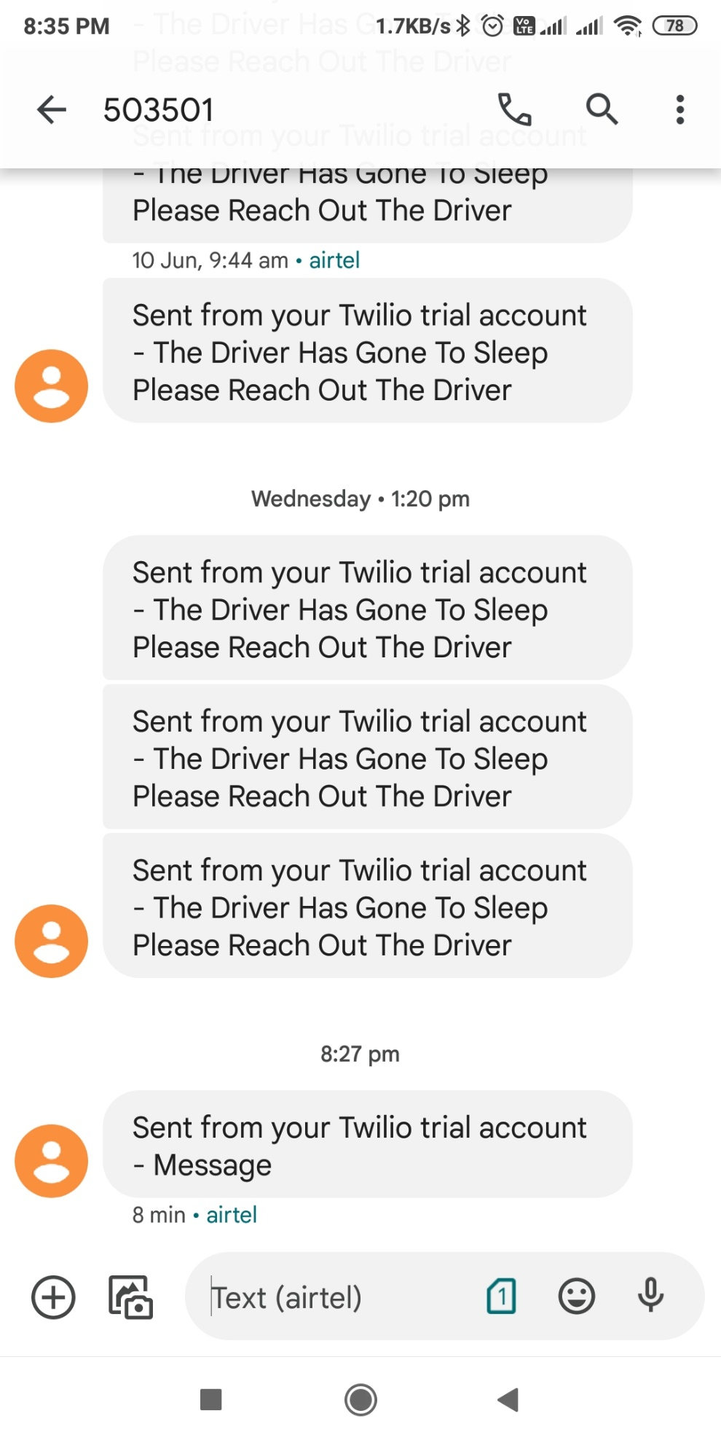

WhatsApp Message

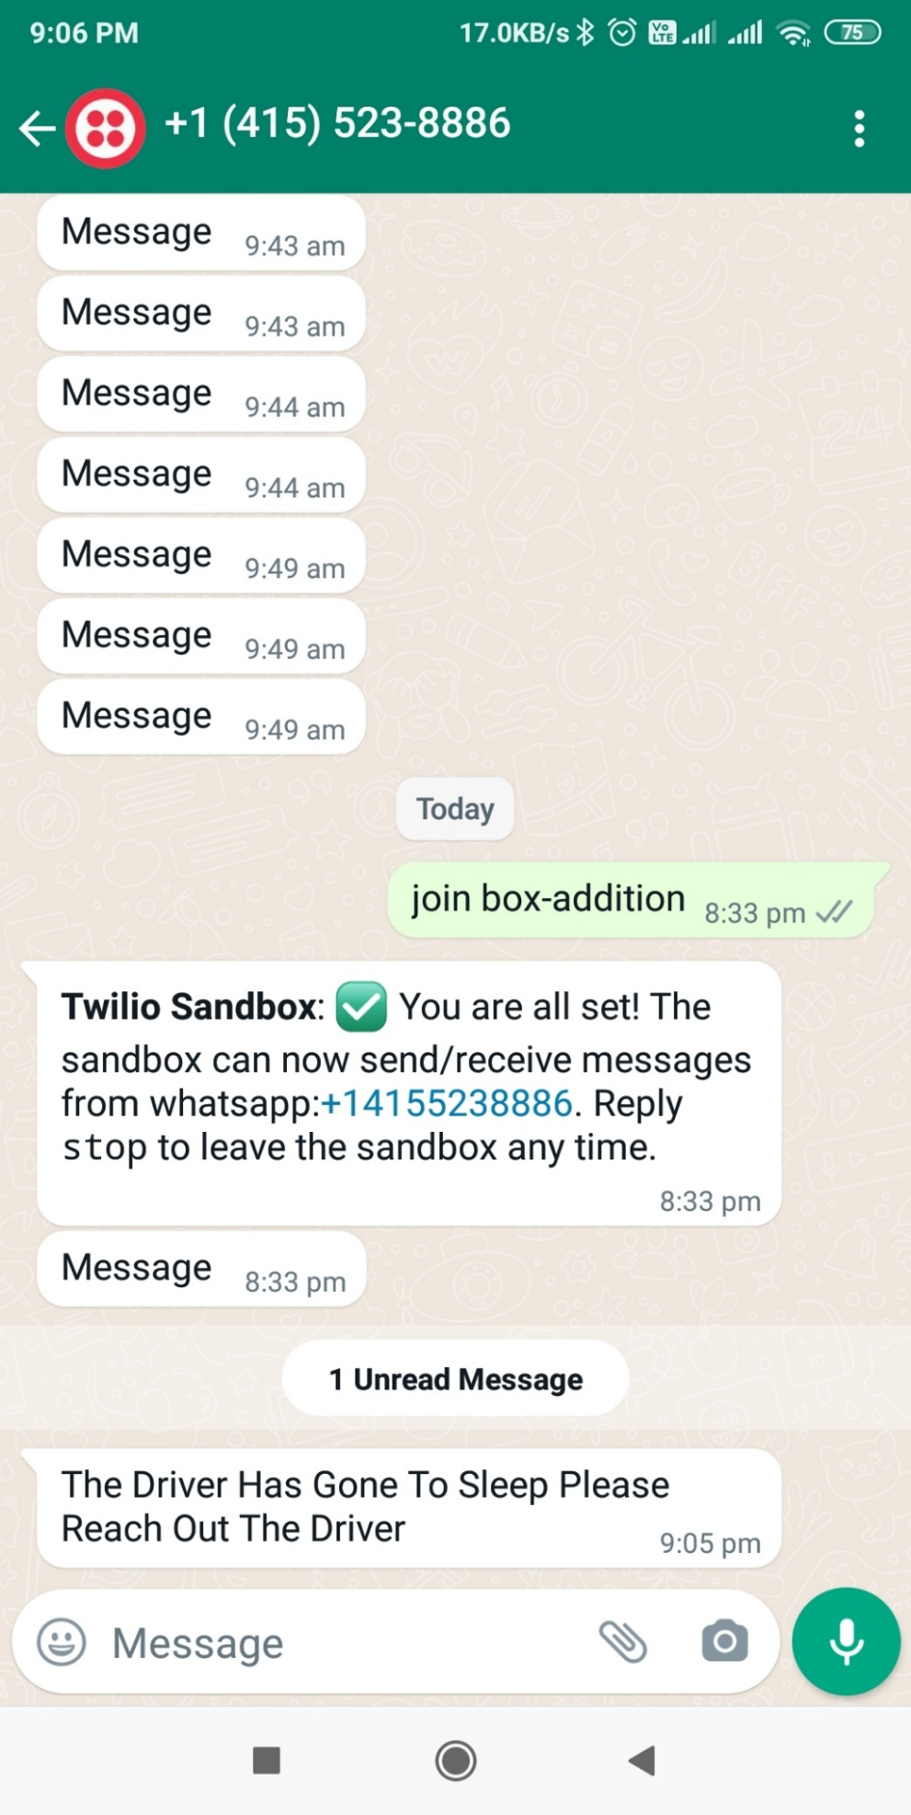

Email Message

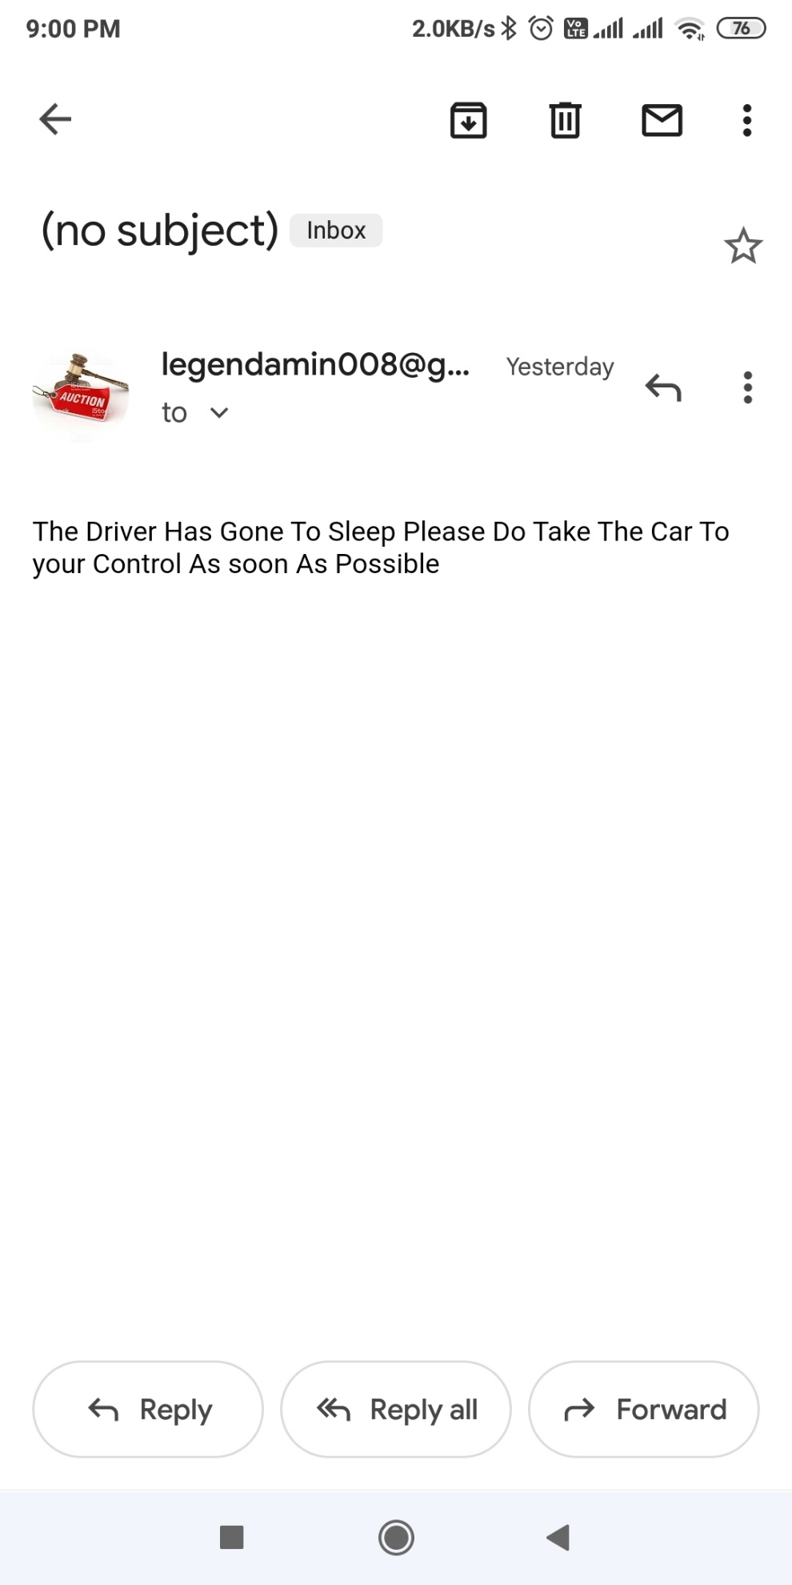

**9. CONCLUSION**

The study has shown promising results in applying the vehicular driver surveillance based on artificial vision techniques and implemented. It completely meets the objectives and requirements of the system. By only concentrating on eyes, we developed a good system that is useful for drivers. Though it cost less to add up camera and alarm system it can be affordable to everyone. The cost of vehicles is less with greater technology inside. There are some promising components such emergency contacts in case the driver goes to sleep it’ll automatically alerts his emergency contacts messaging and email.

**10. Future Enhancements**

The model can be improved incrementally by using other parameters like blink rate, yawning, state of the car, etc. If all these parameters are used it can improve the accuracy by a lot.

We plan to further work on the project by adding a sensor to track the heart rate in order to prevent accidents caused due to sudden heart attacks to drivers.

Same model and techniques can be used for various other uses like Netflix and other streaming services can detect when the user is asleep and stop the video accordingly. It can also be used in application that prevents user from sleeping.

**11. Bibliography**

[1] BOOK- COMPUTATIONALLY EFFICIENT FACE DETECTION; B. SCHLKOPF-A. BLAKE, S. ROMDHANI, AND P. TORR.

[2] BOOK- JAIN, “FACE DETECTION IN COLOR IMAGES; R. L. HSU, M. ABDEL-MOTTALEB, AND A. K. JAIN.

[3] BOOK- OPEN/CLOSED EYE ANALYSIS FOR DROWSINESS DETECTION; P.R. TABRIZI AND R. A. ZOROOFI

[4] PAPER -DRIVER DROWSINESS DETECTION SYSTEMS AND SOLUTIONS; ALEKSANDAR ČOLIĆ, OGE MARQUES, BORKO FURHT

# [5] PAPER -DRIVER DROWSINESS DETECTION USING ANN IMAGE PROCESSING; T. Vesselenyi, S. Moca, A. Rus, T. Mitra and B. Tătaru 2017

[5] <https://en.wikipedia.org/wiki/Driver_drowsiness_detection>

[6] <https://pypi.org/project/dlib/>

[7] <https://opencv-tutorial.readthedocs.io/_/downloads/en/latest/pdf/>

[8] <https://www.twilio.com/>

[9 <https://www.studytonight.com/post/dlib-68-points-face-landmark-detection-with-opencv-and-python>